Darktheme(toggle working) in Favorite page

Workshop #2

Flutter Developer Bootcamp

# **Purpose**

This workshop demonstrates how to create Darktheme(toggle working) and navigate to notification page in favorite page of Empetz app.

# **Problem**

In the given workshop,There will be favorite containing 5 pets name, price and like button icon, toggle and notification icon in app bar, You need to create Darktheme(toggle responsive) and navigate to notification page in favorite page using Gesturedetector. The notification page contains 5 notifications.

# **How to Solve**

1. Checkout the workshop from Git Repo:

git clone -b <user-branch> <repo-URL>

2. Open the root folder inside VS Code

3. Execute the code by running command from the root: <full-command>

4. Implement Darktheme(toggle responsive) and navigate to notification page in favorite page

5. Go To File: <specific-file-with-toggle-bar> à <method-name>, implement your dark theme logic. Make the dark theme and navigation of notification page responsive

**You will Achieve**

When you complete this workshop you will learn the following:

* **Adding toggle for responsiveness**: Learn how to incorporate a toggle switch that enables responsive behavior, particularly with Darktheme functionality.
* **Navigation**: Understand how to implement navigation within your Flutter application.
* **App bars**: Discover how to integrate app bars for navigation and actions.
* **Circle avatars**: Learn to create circular profile images or placeholders using circle avatars.
* **Icons**: Implement icons for visual representation and interaction within your app.
* **Padding**: Explore techniques for adjusting spacing around widgets to enhance layout aesthetics.
* **SizedBoxes**: Learn to manage widget sizes and spacing effectively within your app's layout.
* **Adjusting text alignment**: Gain insights into controlling the alignment of text elements to improve readability and design cohesion.
* **Card:** Organising content in visually appealing, structured formats.
* **Text:** Displaying textual information within the app interface.

# **Screenshots**

## **Before implementation (Favorite page without Darktheme)**

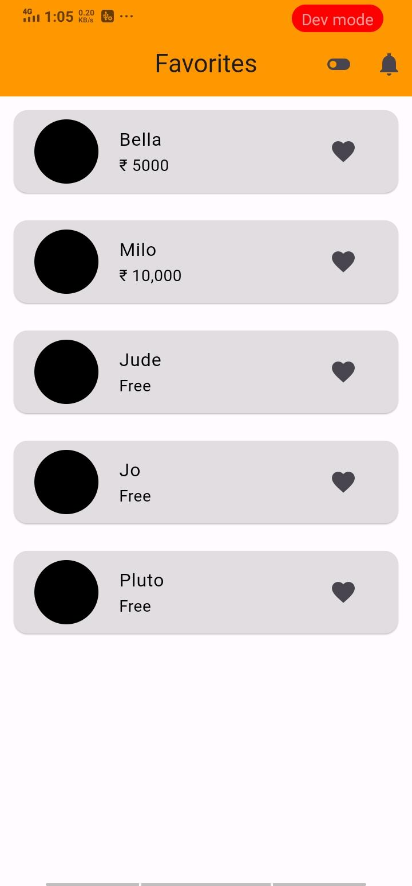

## **After implementation (Darktheme of favorite page)**

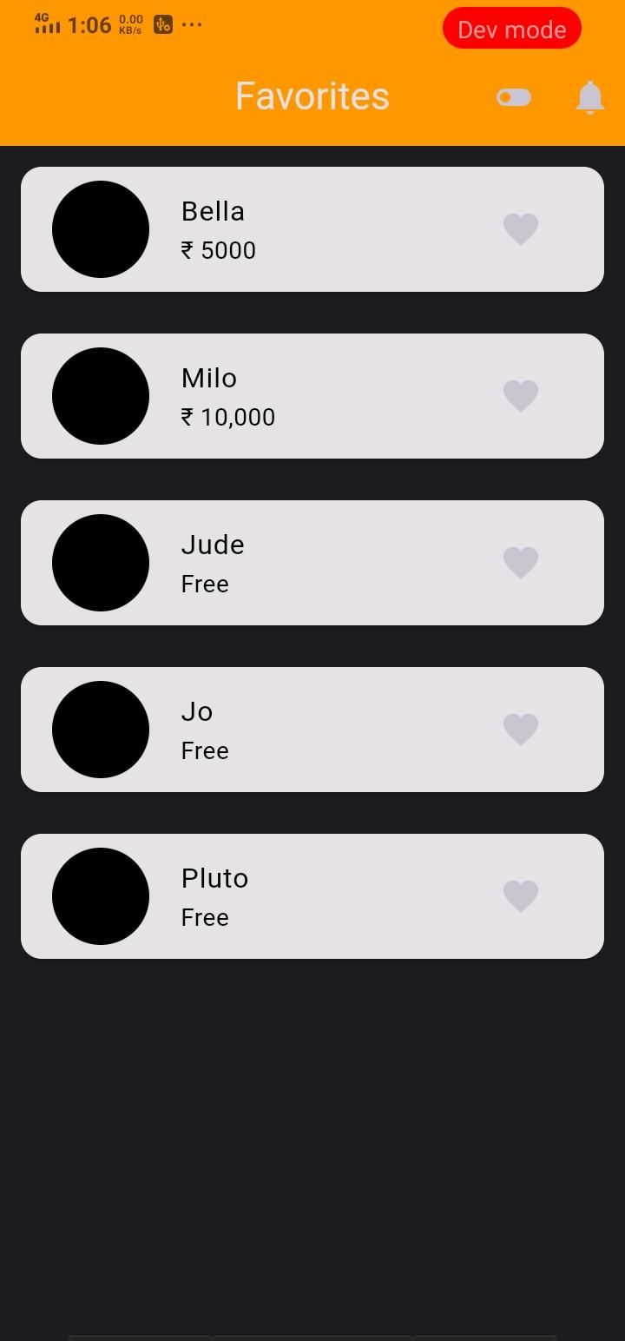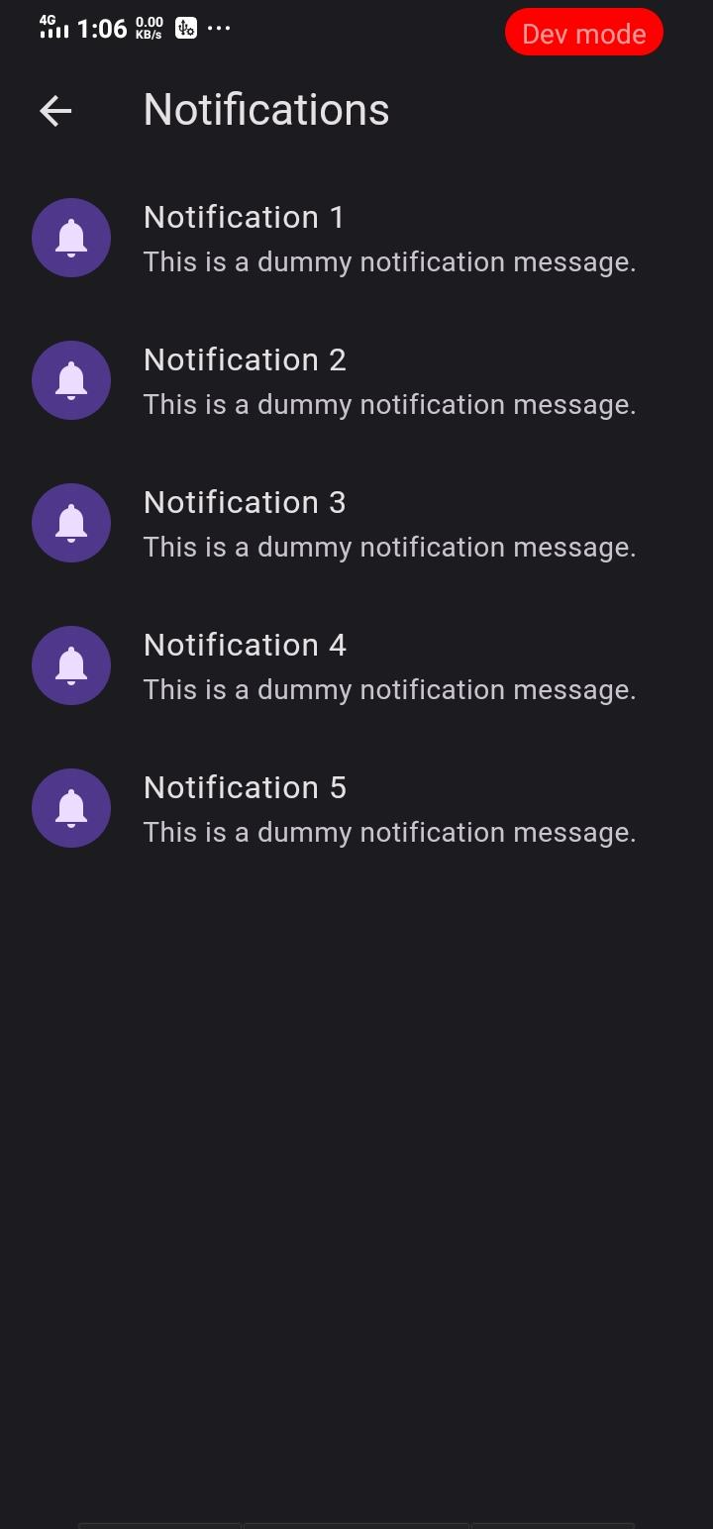

# **How to submit your workshop**

Push your project back to the same git branch using command:

<command name>

# **Happy Coding!**